**me:**

The main aim of this lab session is to provide hands-on experience on

* Getting Help
* Basic Commands
* Navigation
* File System
* simple shell script

1. Getting Help

|  |  |  |  |  |
| --- | --- | --- | --- | --- |
| Task | Command Name | Syntax | Example | Screenshots |
| To get manual page for the known command | man | man | man ls |  |
| To get manual page for the unknown command | apropos | apropos command | apropos ls |  |
| To know the source file binary | whereis | whereis [options] filename | whereis ls |  |
| To know the path of the command | which | which [filename] | Which bash |  |
| To know the command is external or internal | type | type [options] command | type cd  type mv |  |
| To get help for the internal command | help | help | help cd |  |
| To list out bash commands | compgen -c | compgen -c | compgen -c |  |
| To know the usage of the command | man | man | man ls |  |

1. **Basic Commands**

|  |  |  |  |  |
| --- | --- | --- | --- | --- |
| Task | Command Name | Syntax | Example | Screenshots |
| To know today’s date | date | date [option] [format] | date |  |
| To print calendar | cal | cal | cal |  |
| To print kernel version | uname | uname [option] | uname -r |  |
| To print default shell | echo $SHELL | echo $SHELL | echo $SHELL |  |
| To print currently logged in user | whoami | whoami | whoami |  |
| To create shortcut for command | alias | alias name = ‘command’ | alias list=’ls -l’ |  |
| To delete shortcut | unalias | unalias [option] [alias_name] | unalias list |  |
| To change the timestamp of the file | touch | touch filename | touch hello |  |
| To clear the screen | clear | clear | clear |  |
| To create empty files | touch | touch [options] filename | touch Vaibhav.txt |  |
| To know disk usage | df | df [options] [filesystems] | df |  |
| To know free space in the system | df | df [options] [filesystems] | df -h |  |
| To know about the Linux release | cat /etc/os-release | cat /etc/os-release | cat /etc/os-release |  |

1. **Navigation**

|  |  |  |  |
| --- | --- | --- | --- |
| Task | Command | Syntax | Screenshots |
| To navigate home directory | cd | cd ~ |  |
| To navigate to the parent directory | cd | cd .. |  |
| To navigate to the child directory | cd | cd child_directory_path |  |
| Alternate command to cd | pushd | pushd path |  |
| To go back to the previous directory | cd | cd - |  |
| To go to the root directory | cd / | cd / |  |

1. **File System**

|  |  |  |
| --- | --- | --- |
| **Task** | **Syntax** | **Command** |
| **How to identify the file system** | **df -T** |  |

1. Create Folder “CYS”   
   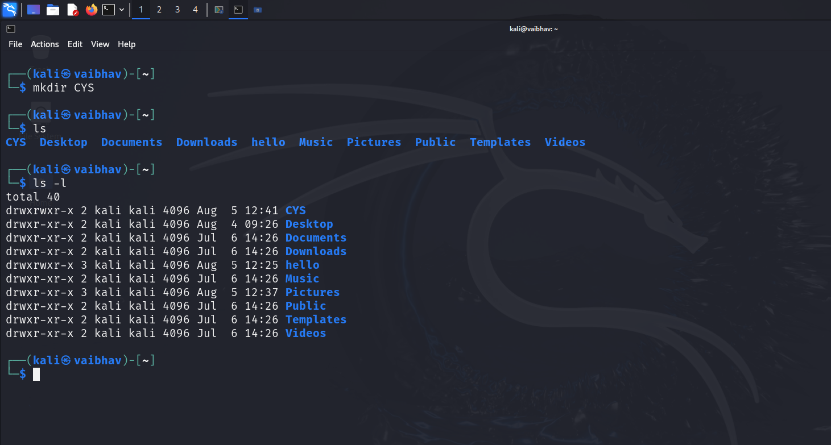
2. Navigate to CYS   
   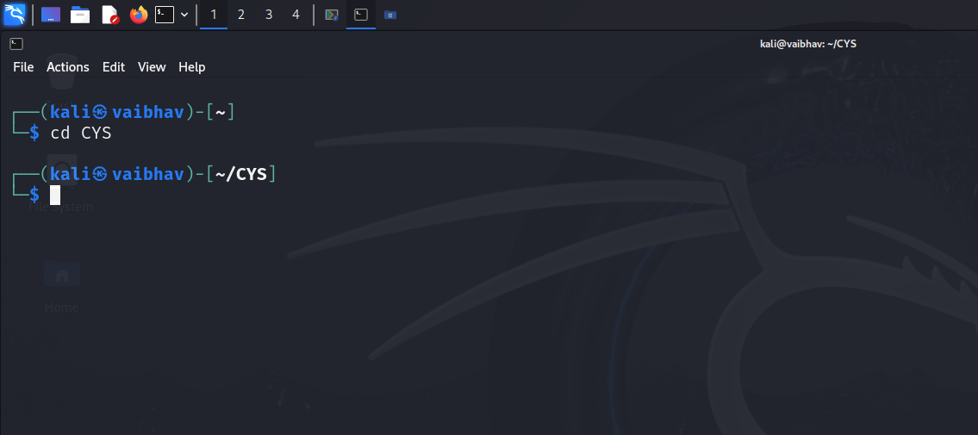
3. Create folder LS1 and LS2 under CYS   
   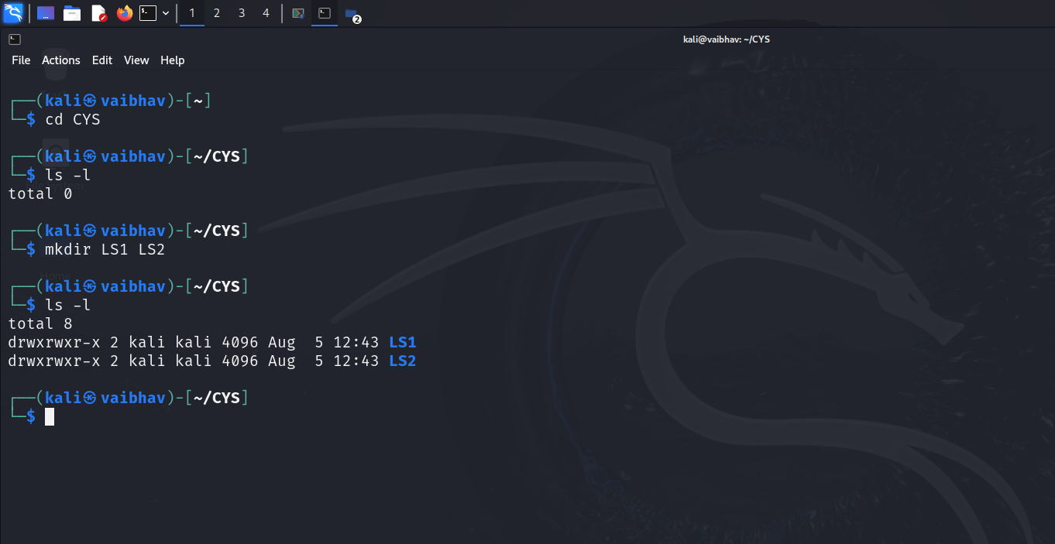
4. Go back to CYS  
   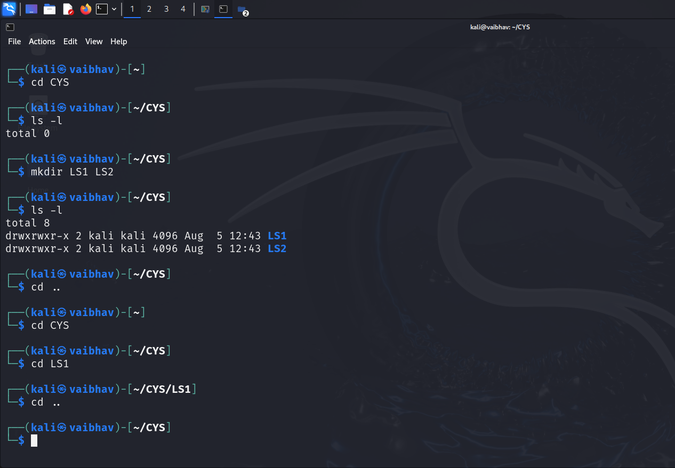

1. Working with Files
2. Add commands which you learnt during lab session in the file commands.txt   
   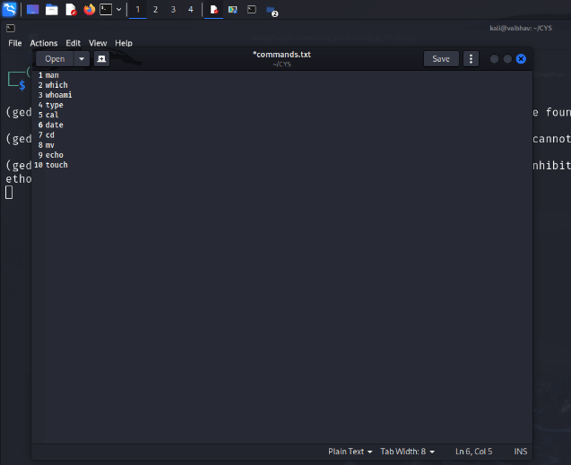
3. Copy the contents from the file commands.txt to commands_demo.txt  
   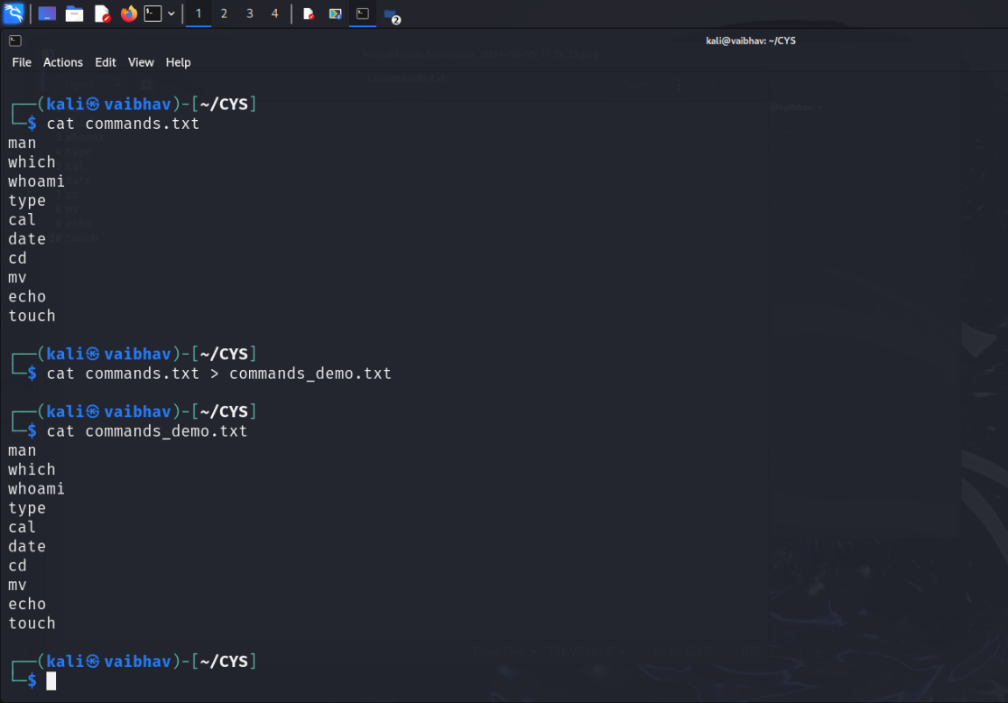
4. Rename the file commands_demo.txt to duplicate   
   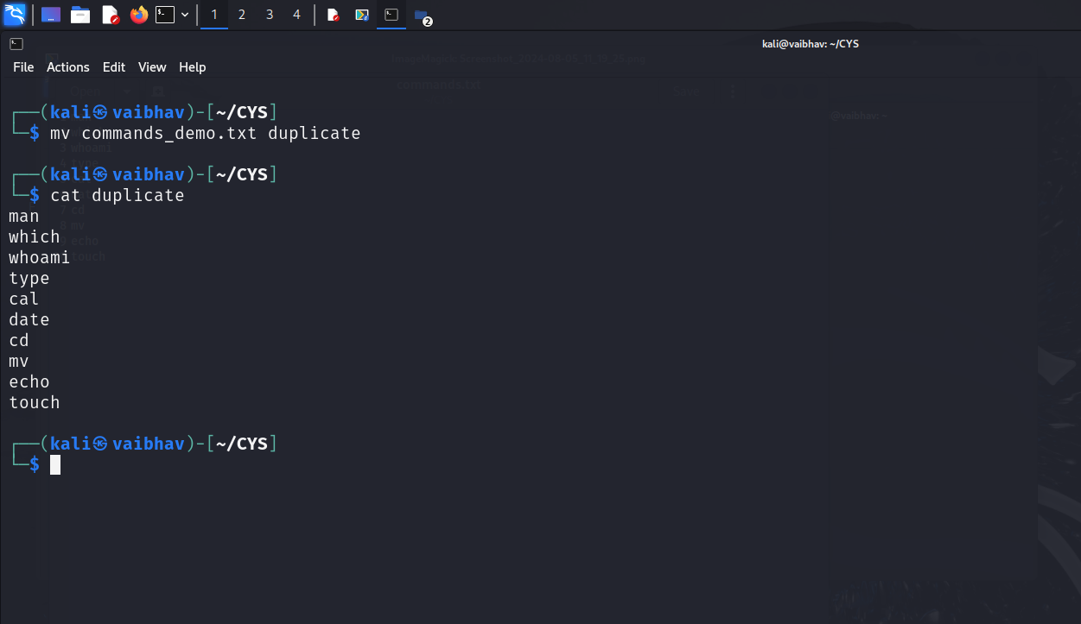
5. Rename all .html to .hldd  
   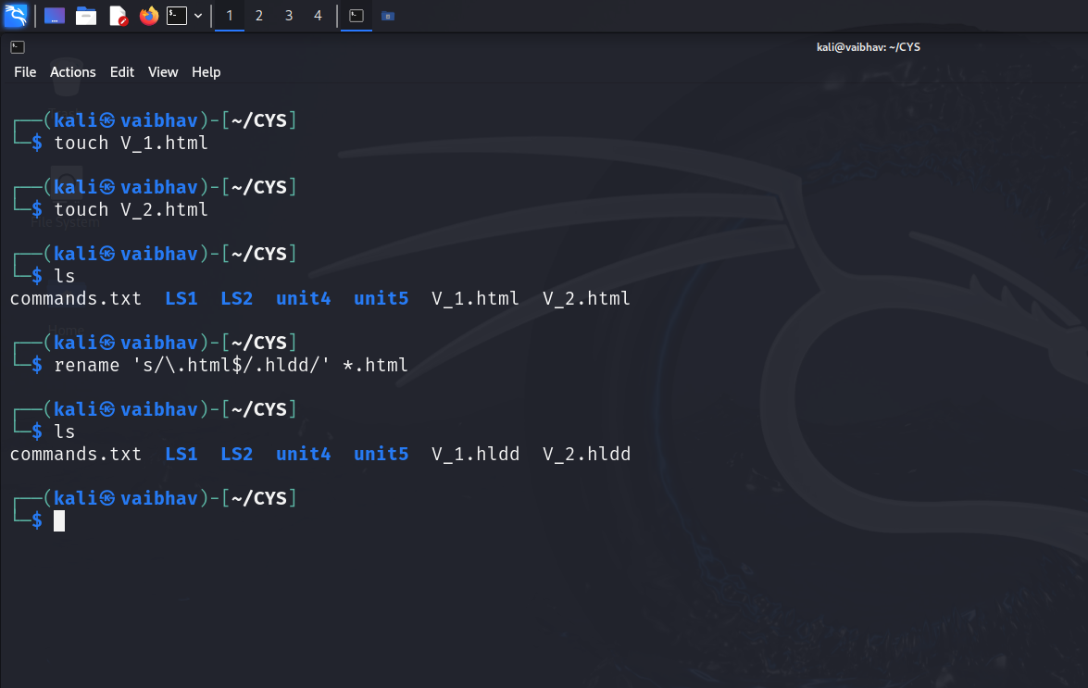
6. Delete the file duplicate   
   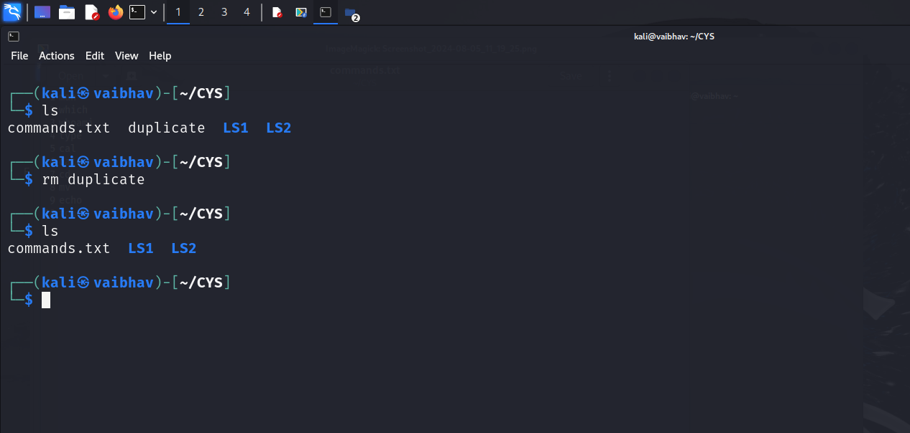
7. Copy the contents commands.txt to unit4 and unit5 (using relative path)

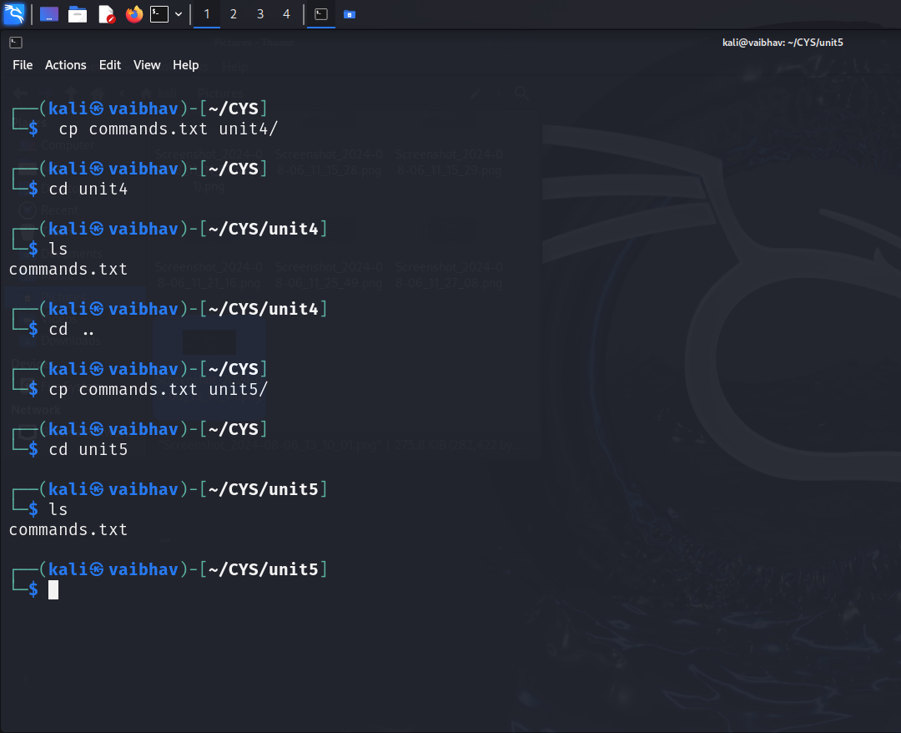

1. Delete the contents from unit5 (using absolute path)   
   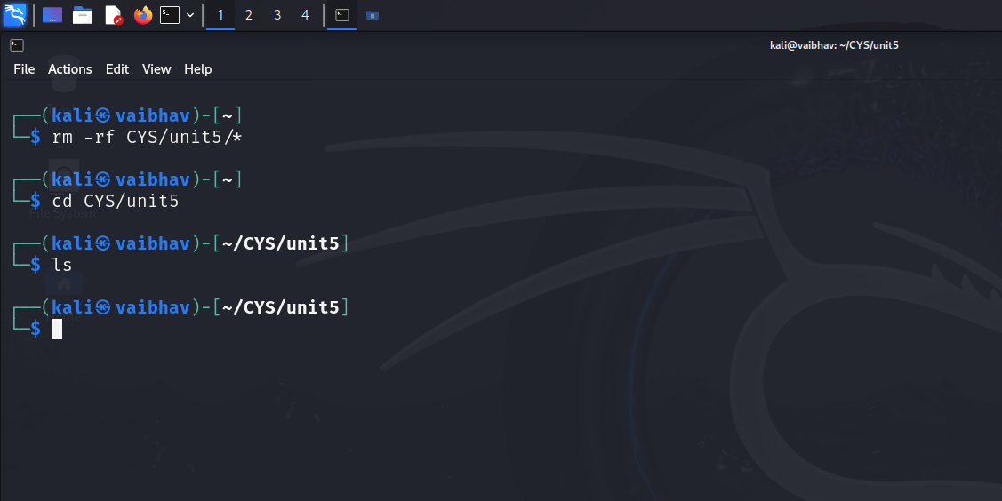
2. Navigate to root  
   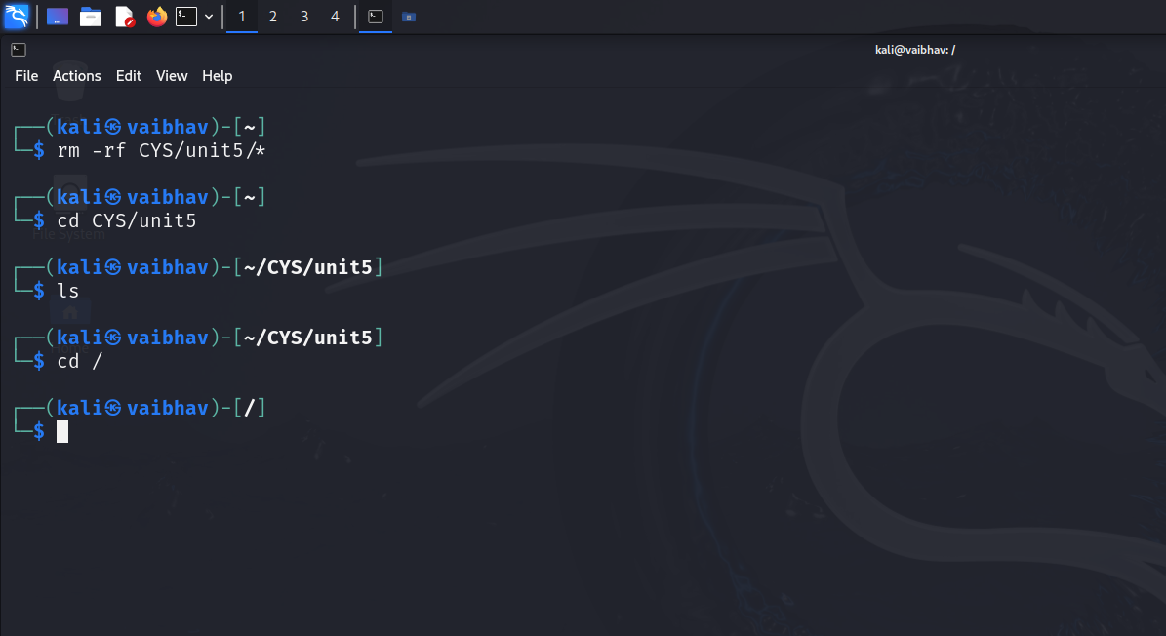

1. List all the files under root  
   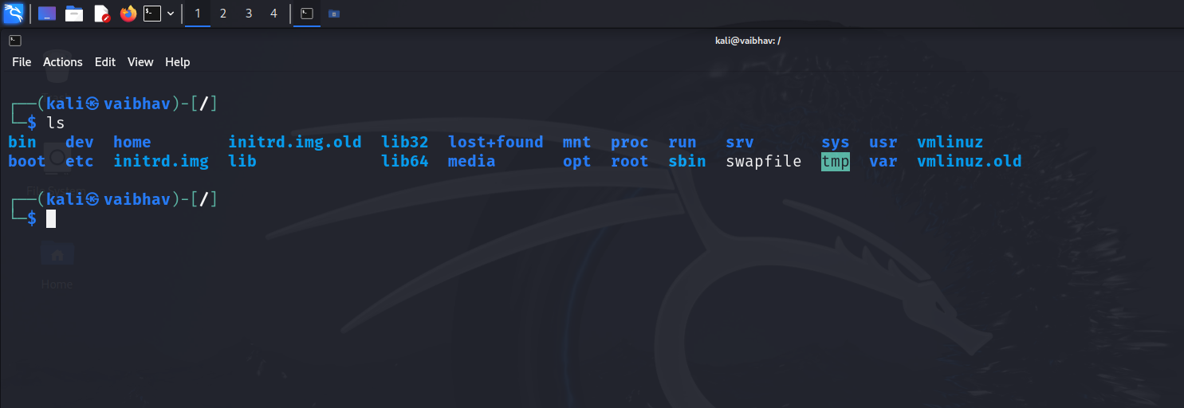
2. Explore all the folders (Do not delete any folder)   
     
   Explored all the files
3. Navigate to /etc/passwd  
   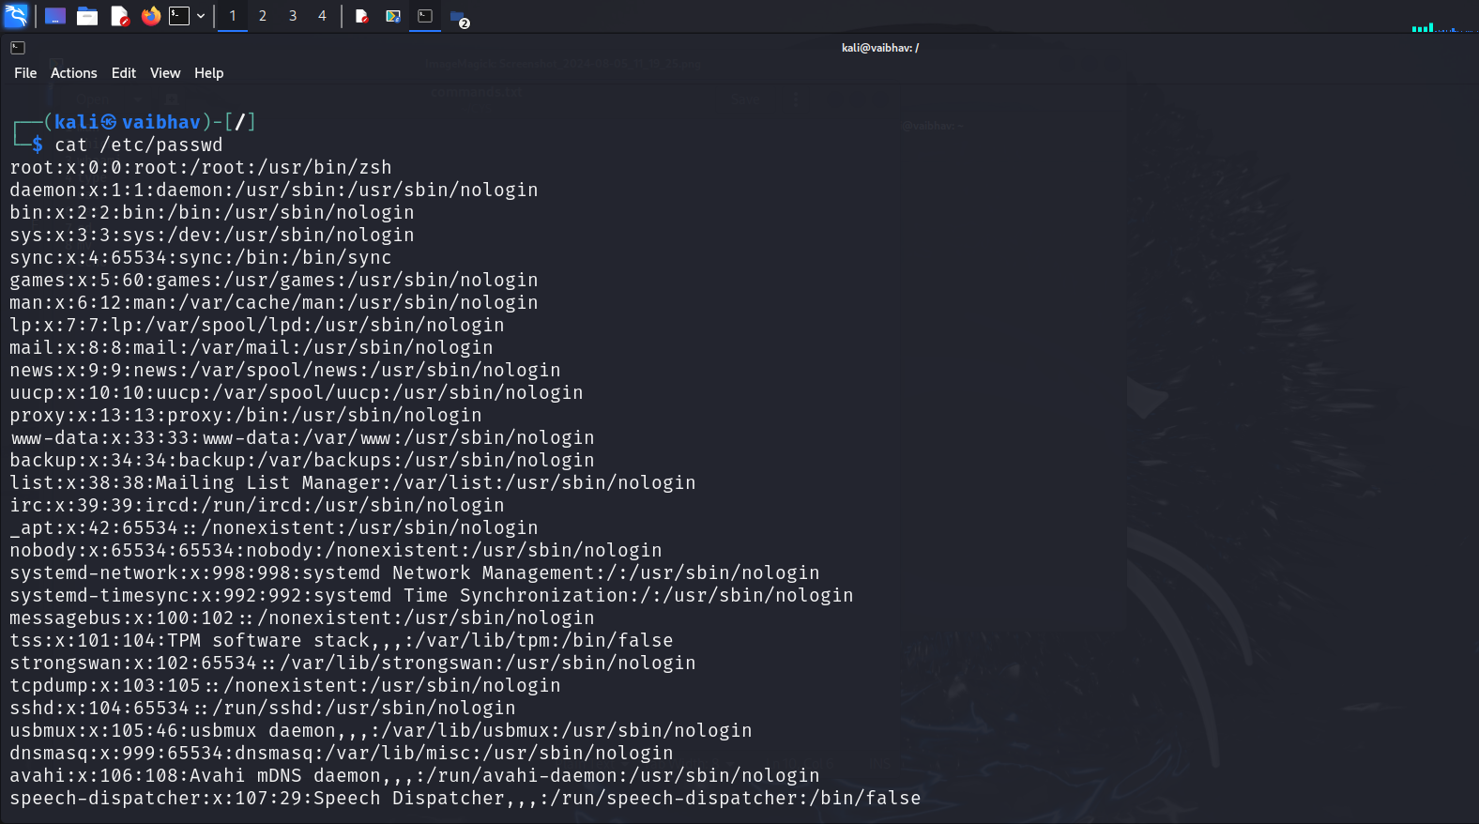
4. Open the file passwd   
   
5. Explore the file passwd



1. Navigate to /etc/group and explore   
   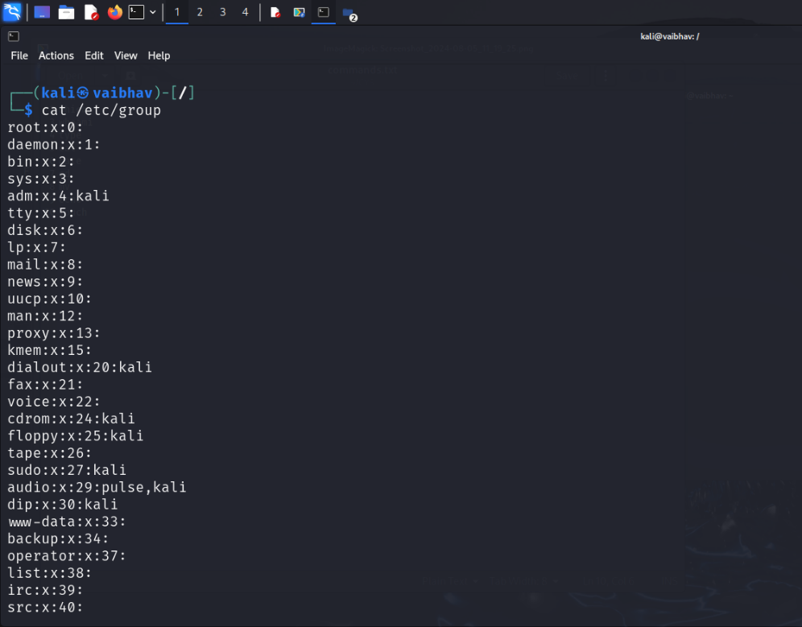
2. **Difference between** 
   * + 1. GUI vs. CLI

|  |  |
| --- | --- |
| **GUI** | **CLI** |
| 1)Visual Representation | 1)No visual representation and text only |
| 2)Slower due to graphical overhead | 2)Faster compared to GUI |
| 3)High resource usage | 3)Low resource usage |
| 4)User Friendly | 4)Less user friendly as it requires knowledge of command syntax. |

* + - 1. man vs info

|  |  |
| --- | --- |
| **man** | **info** |
| 1)Access manual pages for commands | 1)Access GNU documentation |
| 2)Standard on most unix like system | 2)Specific to GNU software |
| 3) Older, traditional method for unix documentation | 3) Interactive,often with a table of contents |
| 4)text based | 4) Hypertext-like, with links and hierarchical structure |

* + - 1. which vs. whereis

|  |  |
| --- | --- |
| **which** | **whereis** |
| 1) Locate the executable file associated with a command | 1) Locate binary, source, and manual page files for commands |
| 2)Provides the path of the executable file for a given command   |  | | --- | |  |  |  | | --- | |  | | 2) Provides paths for binary, source, and man page files related to the command |
| 3) Faster as it searches only PATH directories | 3) Slower as it searches multiple directories and types of files |
| 4) eg: which ls | 4) eg: whereis ls |

* + - 1. Terminal vs shell

|  |  |
| --- | --- |
| **Terminal** | **Shell** |
| 1) Terminal provides a user interface to interact with the operating system | 1) A shell is a command-line interpreter that processes user commands, executes them, and provides the command-line environment. |
| 2) Provides the interface where commands are entered and results are shown.   |  | | --- | |  |  |  | | --- | |  | | 2) Processes commands entered by the user and gives the output for it. |
| 3) Receives input from the user and sends it to the shell for processing. | 3) Processes and executes the commands received from the terminal. |
| 4) Not involved in command processing,only provides a platform for shell commands. | 4) Includes built-in commands for various tasks. |

1. Write a simple shell script to print your name and your hobbies!   
   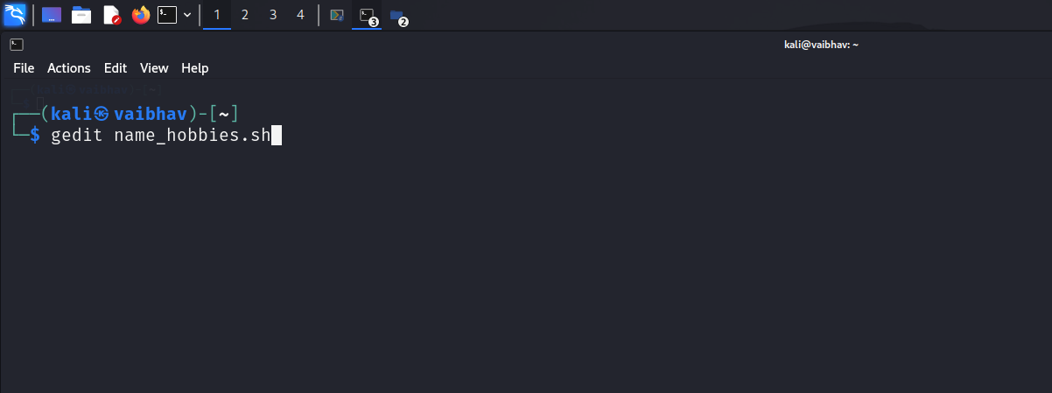

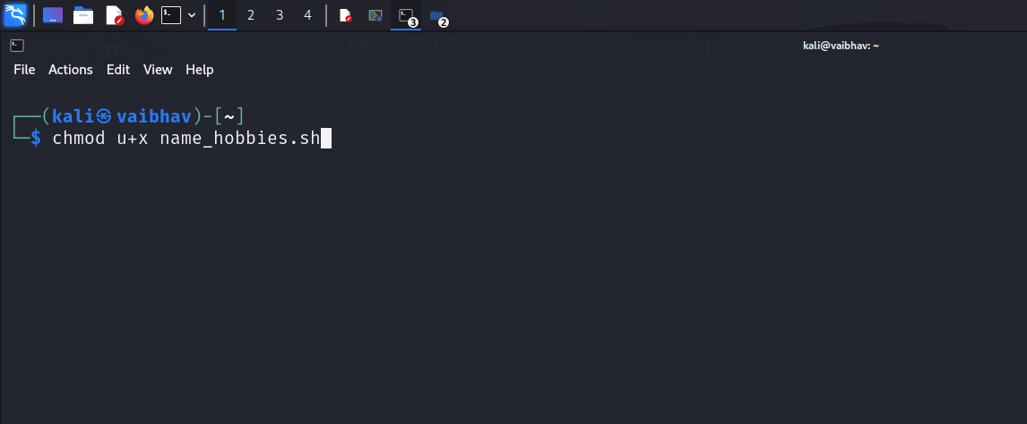  
  
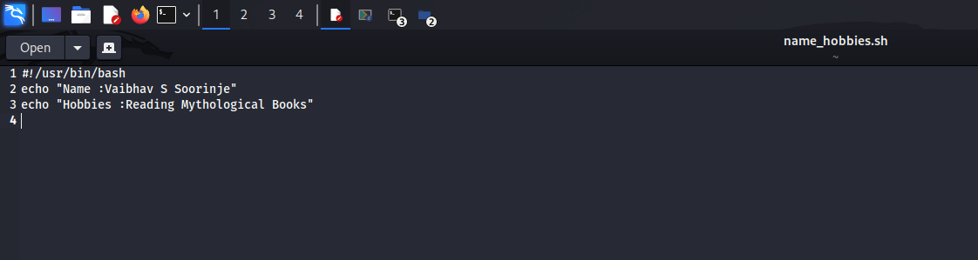  
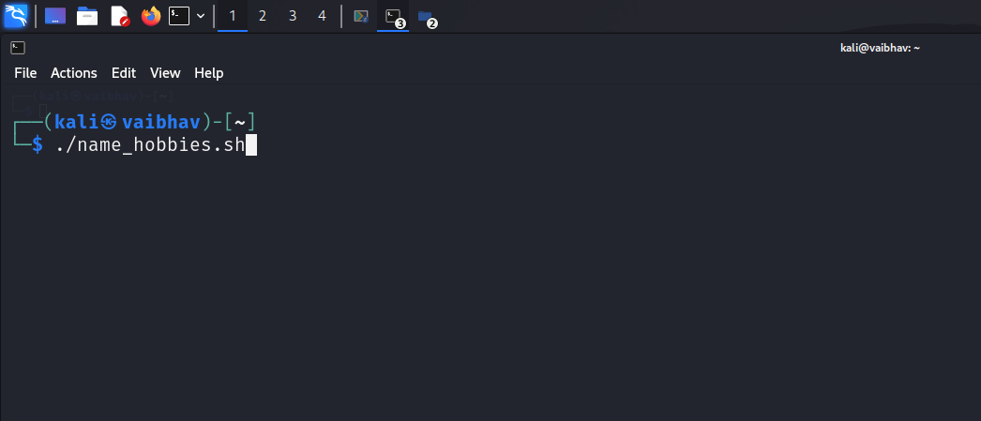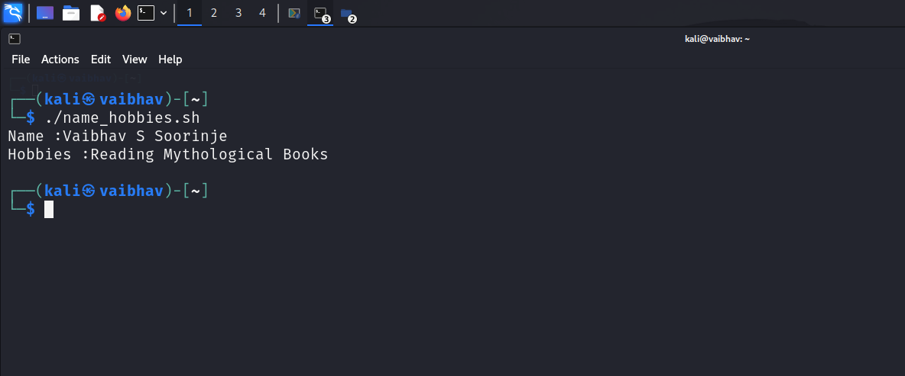

**Interesting commands to Explore**

Banner

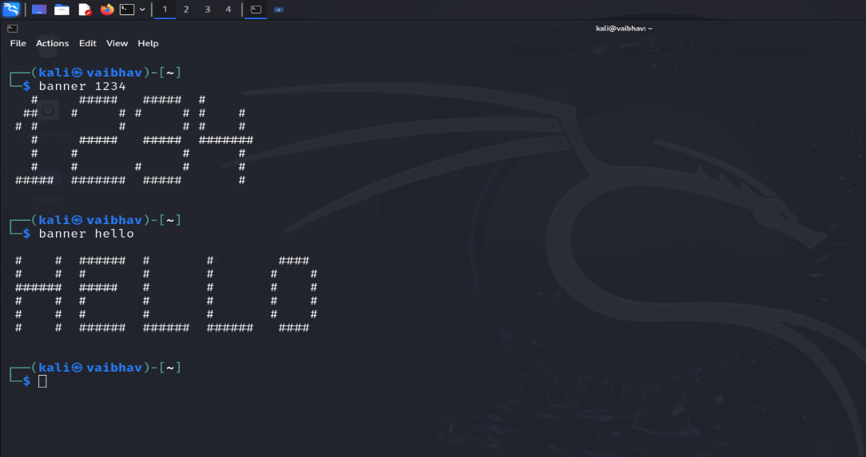

History

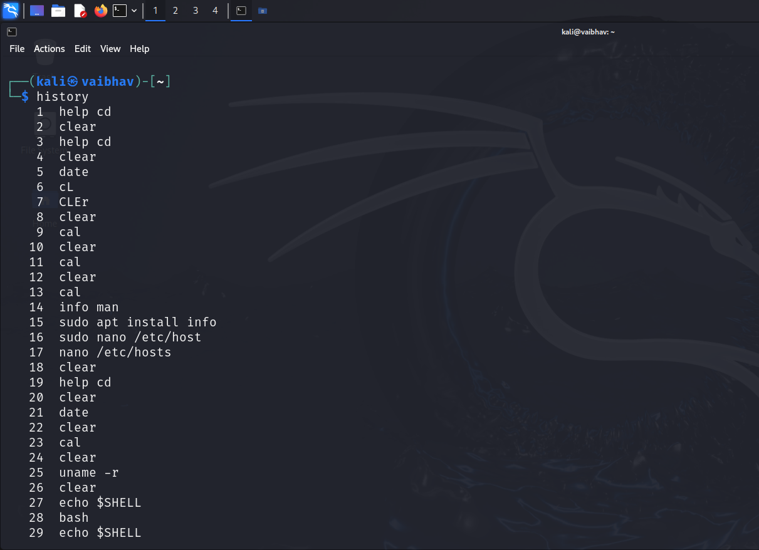

**Note:** Include your screenshots

Evaluation :

Marks : 10 (Deadline : 4 – Originality :3 – Completeness :3 )

Deadline: 06.08.2024

“All our dreams can come true if we have the courage to pursue them.”

Walt Disney